CAMACO

DIE DESIGN & BUILD STANDARDS

Table of Contents

REVISIONS…………………………………………………………………… PAGE 4
1 DIE DESIGN SUBMISSION…………………………………………………. PAGE 5
2 DIE DESIGN………………………………………………………………….. PAGE 5
3 DIE SETS……………………………………………………………………… PAGE 6
4 STOP BLOCKS AND SAFETY........................................................................ PAGE 7
5 SUB-PLATES..................................................................................................... PAGE 7
6 STRIPPER PLATES.......................................................................................... PAGE 7
6 STRIPPER PLATES CONT’D……………………………………………….. PAGE 8
FIGURE 25.0……………………………………………………………………… PAGE 9
FIGURE 4.0………………………………………………………………………. PAGE 10
FIGURE 5.0-1.......................................................................................................... PAGE 11
7 DIE SECTIONS ……………………………………………………………… PAGE 12
8 BLANK PUNCHES ………………………………………………………….. PAGE 12
9 PIERCE PUNCHES ………………………………………………………….. PAGE 12
9 PIERCE PUNCHES CONT’D……………………………………………….. PAGE 13
10 PIERCE BUSHINGS ………………………………………………………… PAGE 13
11 PIERCE INSERTS …………………………………………………………… PAGE 13
FIGURE 6.0-1…………………………………………………………………….. PAGE 14
12 PILOTS ……………………………………………………………………….. PAGE 15
13 PILOT BUSHINGS …………………………………………………………... PAGE 15
14 DRAW AND FORM PUNCHES …………………………………………….. PAGE 15
15 CAMS ………………………………………………………………………… PAGE 15
FIGURE 14.0-2…………………………………………………………………… PAGE 16
FIGURE 14.0-1…………………………………………………………………… PAGE 17
16 FRENCH STOPS …………………………………………………………….. PAGE 18
17 KEEPER BLOCKS ………………………………………………………….. PAGE 18
18 NITROGEN MANIFOLD …………………………………………………… PAGE 18
FIGURE 16.0-1 ………………………………………………………………….. PAGE 19
19 GUIDE RAILS ………………………………………………………………. PAGE 20
20 WEAR PLATES ……………………………………………………………… PAGE 20
21 DIE PROTECTION ………………………………………………………….. PAGE 20
FIGURE 20.0-1A ………………………………………………………………… PAGE 21
FIGURE 20.0-4A ………………………………………………………………… PAGE 22
FIGURE 21-A ……………………………………………………………………. PAGE 23
FIGURE 21-B …………………………………………………………………….. PAGE 24
22 KEYS …………………………………………………………………………. PAGE 25
23 STAMPS............................................................................................................. PAGE 25

TABLE OF CONTENTS

24 PARALLELS ……………………………………………………………….. PAGE 25
25 STOCK LIFTERS .. …………………………………………………………. PAGE 25
FIGURE 22.0-1 …………………………………………………………………… PAGE 26
FIGURE 22.0-2 …………………………………………………………………… PAGE 27
FIGURE 24.0-1 …………………………………………………………………… PAGE 28
FIGURE 24.0-2 …………………………………………………………………… PAGE 29
26 CUT OFF STATION………………………………………………………….. PAGE 30
27 FASTENERS AND DOWEL PINS ………………………………………….. PAGE 30
28 QUICK DIE CHANGE ……………………………………………………….. PAGE 30
29 SAFETY BLOCK AREAS……………………………………………………. PAGE 30
30 DIE HANDLING……………………………………………………………… PAGE 30
31 GENERAL NOTES…………………………………………………………… PAGE 31
31 GENERAL NOTES CONT’D………………………………………………… PAGE 32
32 STANDARD TERMS AND CONDITIONS ………………………………… PAGE 33
32 STANDARD TERMS AND CONDITIONS CONT’D………………………. PAGE 34
33 PRESS STANDARDS………………………………………………………… PAGE 35
PRESS CHART…………………………………………………………………… PAGE 35
PRESS CHART CONT’D………………………………………………………… PAGE 36
PRESS CHART CONT’D. ……………………………………………………….. PAGE 37
PRESS CHART CONT’D. ……………………………………………………….. PAGE 38
MW ELECTRONIC TRANSFER ……………………………………………….. PAGE 39
MW MODES OF OPERATION …………………………………………………. PAGE 40
TRANSFER PRESS ……………………………………………………………… PAGE 41
34 TOOL PROGRESS REPORT………………………………………………… PAGE 42
35 IN-DIE LUBRICATION……………………………………………………… PAGE 42
ATTACHMENTS LIST ………………………………………………………….. PAGE 42
EXHIBIT A ………………………………………………………………………. PAGE 43
EXHIBIT B1……………………………………………………………………… PAGE 44
EXHIBIT B1 CONT’D. ………………………………………………………… PAGE 45
EXHIBIT B2……………………………………………………………………… PAGE 46
EXHIBIT B3 …………………………………………………………………….. PAGE 47
EXHIBIT C……………………………………………………………………….. PAGE 48

Revisions

Rev A Updated by Dan E. Auble, 7/23/2008 to meet equipment installed and CAMACO Lorain Manufacturing and new tool build requirements.
The purpose of these specifications is two-fold. First, it is intended as a summary of the high standards of excellence expected by Camaco and its customers. Secondly, it is intended as a blueprint for standardization and safety to give Camaco vendors a concise picture of tooling specifications.

1. DIE DESIGN SUBMISSION

1.1 A REPRODUCIBLE COPY OF A COMPLETE DIE DESIGN IS TO BE SUBMITTED TO Camaco for design approval signed by both parties. Camaco will not accept responsibility for any purchased items or work performed on any tooling prior to design approval. Die design approval does not in any way relieve the vendor of responsibility for the function, performance and dependability of the tooling and timing stated in our P.O. (Exhibits B1,B2,B3)

2. DIE DESIGN

A complete die design must include all of the below and submitted prior to run off at Camaco:
2.1. A strip layout showing progression and all stations.
2.2 Top and bottom plan views.
2.3 Sufficient section views.
2.4 A complete set of drawing in 8.5” x 11” format
2.5 Detail Drawings must be of sufficient detail and clarity to enable manufacture of replacement parts. If in the
case of 3D machined Punches/Dies etc. full dimensions are not possible, a 3D CAD model, sufficient to produce an NC program, should be supplied.
2.6 An accurate bill of material including purchased parts (punches, bushings, springs, etc.).
2.7 CAD files in Unigraphics.PRT files, DXF or IGES S.T.E.P.FORMAT Auto CAD 14 or higher
2.8 Spare part list/Dwg Excel
2.9 Tool Design Tracings are property of Camaco and are to be delivery to Camaco, at the time of die delivery. Tracings must be reproducible.
2.10 Current engineering level X-Y-Z printouts, N.C. and EDM wire cut programs are to be delivered with the tool drawings.
2.11 All punches, buttons, and other purchased perishable items shall be designed and detailed. Use only Moeller unless authorized in writing by Camaco.
2.12 Detail numbers and balloons to be in plain view as much as possible. Each detail balloon will be ½” diameter and will be split. The top number will be the detail number and the bottom number will be the sheet number where the detail is dimensioned out.
2.13 All roll size drawings are to be on 36” or 42” paper.
2.14 The tooling source is to provide a timing chart for the entire program at the start of the tool program. (Exhibit A), to be updated by 8:00a.m. each Monday.
2.15 Tool numbers to be on all drawings and tools as provided by Camaco.
2.16 Dies must be designed to the press specifications they are assigned to.
- Proper shut height
- Equal shut height on multiple dies running in the same press
- Proper feed height
- Proper cushion pin pattern and size
- Proper locating system
2.17 Unless process dictates a different clearance and is approved by Camaco, a 7%-10% per side cutting clearance will be required on all material thicknesses. In a note near the title block, specify the cutting clearance used.

2.18 Tool Shop is responsible for the design of the poke yoke system using 24 volt PNP sensors (Pepperl+Fuchs) and (Wire-Bus system).

3. DIE SETS

Die sets must:
3.1 Be blanchard ground and stress relieved with the shoe thickness being 3.0”/75mm if the die is less than
60”/1500mm in length and 4.0”/100mm if the shoe is over 60”/1500mm.
3.2 Have 4 posts 2” – 50mm diameter if under 72” and 6 posts 3” – 75 mm diameter if over 72” /1800mm.
3.3 Be made foolproof by the offsetting of one pin.
3.4 Have a total of 8 lifting holes, 1.0-8 UNC/M24x3 positioned evenly as well as 8 lifting bars welded to die shoe, according to weight to allow for easy flipping of the die without the disassembly of the nitrogen, etc.
3.5 Have the Camaco supplied die number, strip width, thickness and progression stamped on the bottom shoe and a letter AF=on the front.
3.6 The right front edge of punch holders is to be milled smooth for an area as needed to stamp as follows:
- Property of
- Part No.
- Material
- Material thickness
- Cutting clearance
- Progression
- Outside shut height
- Cushion pin length above bolster
- Built by
- Top shoe weight
- Tonnage
3.7 Ford tooling requires an additional brass tag stating ‘PROPERTY OF FORD MOTOR COMPANY”, PART NUMBER, JOB NUMBER, AND CHANGE NUMBER.
3.8 Total weight to be stamped on bottom shoe of die. Top shoe die weight is to be stamped on the top shoe.
3.9 Good engineering judgment is required to ensure that all castings or weldments are designed with sufficient strength to perform the required die function. For large cast iron dies, follow section 8060-03 (GM246 or GM190) or cast DZ sections.
3.10 In castings, provide cored relief to reduce weight without compromising strength.
3.11 Break all sharp outside edges of die shoe weldments.
3.12 Use bosses on the top shoe equal in height to the upper components. This will keep the lower guide pins short enough to allow transferring the parts from station to station.
3.13 All non-ball-bearing sets will have mountable bronze plated shoulder bushings. Ball bearing guide pin to be in all dies that run at 35 strokes or more per minute; plus all dies that run in AIDA Press. All other dies will have non-bearing pins.
3.14 All die sets with heel blocks, as a guiding system must enter 1” – 25mm before guide pins.
3.15 All dies to be painted safety red (Sherwin Williams #4081) unless otherwise specified. (Edges only), unless Camaco customer color code is required. Paint color chips to be supplied by Camaco.
3.16 Closed cut-offs in punching situations.
3.17 In die sets using a wearplate in conjunction with guide pins, fail-safe the heels and use guide pins of the same size.
3.18 If the bushing hole on the top shoe is obstructed by the manifold or parallel, etc. then a vent hole must be drilled 3/8”/10mm diameter (not a groove with a die grinder).
3.19 Have grooves to be milled out between the die shoe and manifold to allow for drainage after die washing.
3.20 Nitrogen holes should be 1/32”/1mm bigger in diameter to ensure removal. They are to include an offset hole to allow for drainage when the cylinder is installed.
3.21 Avoid blind dowel holes where possible. If blind dowel holes cannot be avoided, pull dowels must be used.
3.22 Avoid reamed holes of excessive length in either the die section or the die shoe.
3.23 Dowels to be tap fit into die shoe and slip fit in the hardened die steels.
3.24 No altered, homemade screws or fasteners will be allowed.
3.25 All transfer dies must be die casted (EUR GG-25). Design approval required prior to casting.
3.26 All transfer dies need to be built in and mounted on a Master Die Shoe with Camaco locator pin system . (See FIGURE 25.0) Master Die Shoe to be divided as two (2) pieces.

4. STOP BLOCKS AND SAFETY
4.1 Stop blocks are to be mounted directly above a parallel. Have a ½” wide x .050 deep grove for shut height adjustment.
4.2 Stop blocks must have integrated die set up pins, to be painted red. (Figure 4.0)
4.3 Stop blocks may be round or rectangular. Round blocks will be at least 2” in diameter and increase with tonnage.
4.4 Four stop blocks are required - 4 stop blocks required if under 72”/1800mm and 6 stop blocks required if over 72”/1800mm.
4.5 Locate stop blocks within the ram and bolster area above parallels. Assure location and number of stop blocks provides proper balance of die forces. Locate in an exposed area to aid die setting, but not to interfere with any transfer systems.
4.6 Appropriate guards around the pinch points are required.
4.7 Have hardened plates pocketed in where stripper bottoms out.

5. SUB-PLATES

Sub-plates shall always be included and must:
5.1 Be manufactured from pre-hardened 4140 material or equivalent.
5.2 Be a minimum of 3.0”/75mm thick yet not too large to hinder easy handling.
5.3 Have threaded lifting holes (on top, NOT on sides) to allow easy handling if weight is over 50 pounds.
5.4 Be keyed on the die shoe.
5.5 Clearance between the cut out in the sub-plate and the cut out in the die shoe must not exceed ¼”/6mm
5.6 Clearance between die section cutout and sub-plate cutout to be .100”/2.5mm.
5.7 All cavities to have drain holes for excessive stamping lubricants.

6. STRIPPER PLATES

Stripper plates must:
6.1 Be made of pre-hardened 4140 material or equivalent and a minimum thickness of 2.0”/50mm.
6.2 Strippers must be guided by pins, bushings or inserts whenever one or more of the following conditions exist.
6.2.1 Strippers that contain form and or cutting inserts.
6.2.2 Piloting of part or webbing is done by inserts.
6.2.3 Stripper is used to guide small diameter punches or pilots

Suggested method when forming sections in stripper plate:
Be guided by M.S. case hardened keeper blocks in conjunction with hardened APMCO or equivalent Bronze No. 18 inserts (Figure 5.0-1,) milled into the stripper. (Note: All keeper blocks are to have grease grooves on the front face fed by a grease nipple from the back and should have a 500”/13mm thick retaining lip. There should be no more than .002”/0.05mm clearance between keeper blocks and stripper inserts. (Figure 5.0-1), or the use of guide pins and bushings to guide the stripper, 1” – 25 mm diameter as minimum.
6.3 Have windows where ball lock piercing/punches go through the stripper for easy service while the die is in the press. The window inserts should be of hardened 01 or equivalent material and held in with flat head screws. If this makes the window insert too weak, or if there is not enough space to do so, Camaco must be advised in order to make a decision. Camaco will decide for dies with less than 100,000 hits per year.
6.4 Have stock levelers either pocketed into them or located on the die to prevent the stripper from tipping when starting or finishing a strip. (-005”/0.10”/0.25mm below minimum material thickness)
6.5 Be of reasonable size with lifting holes to allow for easy handling if weight is more than 50 pounds.
6.6 Have 3/8”/10mm plungers on either side of all pilots which come through stripper, thus preventing strip from sticking to pilots. (A Vlier=Type) or equivalent oil breakers.
6.7 When cam piercing, the punches must be stripped using self contained nitrogen gas gas springs (Dadco or Kaller unless otherwise specified). Do not exceed average life deflection.
6.8 Gas spring location on cam strippers must not allow the stripper to be tipped. Gas springs must be positioned for even pressure around the punch. Gas springs used on cam strippers must be used in conjunction with stripper bolts. Pierce punch must be a minimum of .100”/2.5mm below the stripper.
6.9 Have hardened plates wherever the stripper or pressure pads bottom out, also over any cam pierce operation.
6.10 Bottoming block should be mounted to die shoe NOT to stripper.
6.11 Have nitrogen cylinders used with a manifold system or self-contained nitrogen cylinders (no springs) in the main stripper.
6.12 Have stripper clearance to maximum opening of guide rails. (Figure 24.0-1)
6.13 Stripper clearance around punches should be .050”/1mm per side when material is 3mm thick and .100”/2.5mm per side when material is 4-6mm thick. If very small punches are being used, may be stripper guiding is necessary.
6.14 L-gib stripper pad retainers are required. Spool type (Jolico) may be used if authorized in writing by Camaco.
6.15 All strippers must be removable in press.
6.16 No urethane strippers.
6.17 No pre-load on nitrogen cylinders. We must have at least a .020” gap between plate and cylinder.

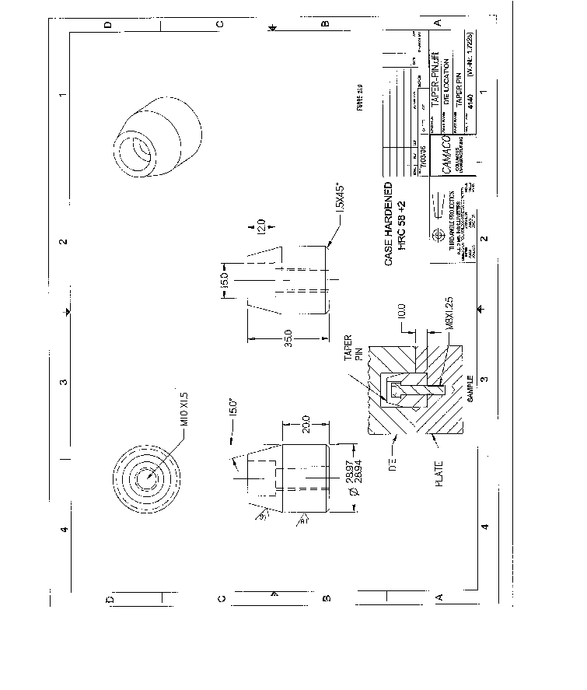

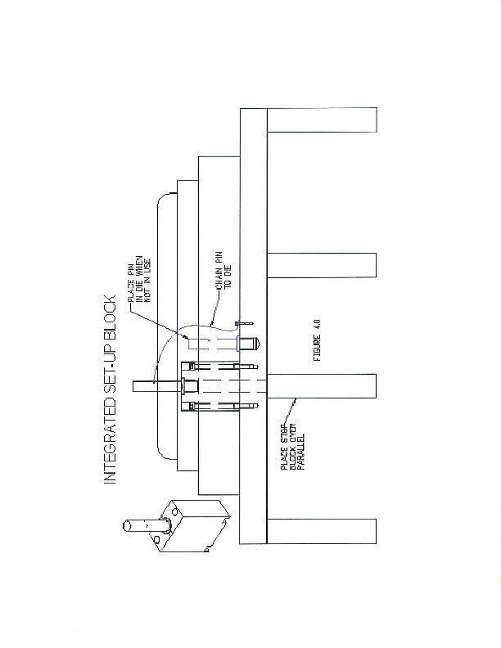
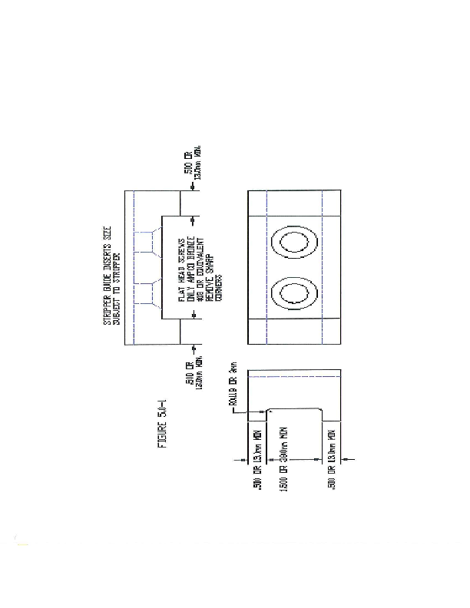

7. DIE SECTIONS

Die sections must:
7.1 Be 2.0”/50mm thick to ensure stability, strength and proper fastening location.
7.2 Be keyed or pocketed in location with all pockets being chamfered. Die section should be above subplate .005”/0.10mm to .010”/0.25mm
7.3 Be of a size 12”x12”/300mmx300mm max to accommodate proper handling, lifting holes required if weight is over 45 pounds.
7.4 Be fastened to the sub-plate or die shoe from inside the die to make them accessible for removal without removing the parallels or sub-plate.
7.5 Also have jack screws, pull dowels and slide fit where necessary to allow for their easy removal.
7.6 Have the first couple threads drilled out of a threaded hole so that the threads will not pull through.
7.7 Have smaller sections within them for easy maintenance (to be discussed at die design). (Note: The clearance between the cut-out in the die section and the cut-out in the sub-plates should be .100”/2.5mm, to gain maximum support for the cutting edge).
7.8 Draw section be out of D2 material or alternate at Camaco’s request at 58 to 60 HRC hardness.
7.9 Rest against at least one side of the pocket in the sub plate whenever possible, or should be doweled if all four sides rest against other die sections.
7.10 Screw holes be counter bored – screws not longer than 25mm and the screw head must be below die life.
7.11 Lifter retaining buttons to be screwed to subplate not die section.
7.12 Have slug retaining wire cut groove in wire cut openings.
7.13 Be cryogenic tempered (if available in Europe).
7.14 Die Section minimum PVD coating for all draw sections or alternate at Camaco’s request.
7.15 All inserted die blocks, sub plates, strippers, etc. shall have a ¼ to 3/8 radii relief.
7.16 Miss match cuts are be included into the trim profile to eliminate burrs from trying to match trim areas. The description or shape of the miss mach will be provided by CAMACO prior to strip layout, no scallop type miss match allowed.

8. BLANK PUNCHES

Blank punches must:
8.1 Be of D-2 material 58-60HRC or A-2 material 60-62 HRC and fitted with slug ejectors. Ejector pins must not fall into previously pierced holes. Ejector pins must be installed in such a way that is prevents the slugs from pulling back (not off tone side).
8.2 Be located in a hardened (54-56HRC) A-2 punch pad (thickness 1.5”/40mm) sitting on and screwed to (not welded) a 0-1 hardened backing plate of 3/8”/10mm thickness wire cut.
8.3 Be the exact progression (+.002”-0/0.05mm) on punches used to cut the French positive stops.
8.4 Be screwed into top for accessibility. (counter bored 1”/25mm deep plus head height of screw)
8.5 Not have heels (Heel block is located in subplate/die section.
8.6 Be cryogenic tempered. (If available in Europe)
8.7 Scrap punches for skeleton cutoff to be designed and built to be useable so punch could be used on 4 sides.

9. PIERCE PUNCHES

Pierce punches must:
9.1 Be of heavy duty ball lock type (wherever specified) NOTE: Ball lock holders are to have backing plate, not plug type holders.
9.2 Be held in a common holder where a cluster of punches is required. This punch pad should be a thickness of 1.5”/40mm sitting on a 0-1 hardened backing plate of 3/8”/10mm thickness
9.3 Be manufactured of A-2, D-2 or M-2 material depending on application with slug ejectors.
9.4 Be made to Dayton Progress standards (length and diameter) and, in the case of a shaped punch, should have a locking device in standard location.
9.5 Be specific to Dayton progress (Catalog type).

9. PIERCE PUNCHES CONT’D.

9.6 Be standardized in cams so when reordering, we are not ordering different punches when one size could be standardized.
9.7 New tools must be supplied with two spares of every size punch and button.
9.8 When tool shops are ordering punches, you should order as follows:
1 I.e. Straight punches (mounting holes) +.0000/-0005” (+0/-013mm) from max tolerance.
2 I.e. 45 degree punches (chamfer punches) – 0000/+.0005” (-0/+013mm) from max tolerance.
9.9 Offset ejector for the side notch punch.

10. PIERCE BUSHINGS

Pierce bushings:
10.1 Be made to standards with locking devices in standard location
10.2 Be, wherever possible, used instead of pierce inserts, or within an insert with a hardened backing plate screwed to the back of the insert. (Note: Pierce bushings must have excessively large holes cleared for the slugs (max. .050”/1.25mm per side). If in a case of a thin wall using (wall thickness .250”/7mm or less) then there must be a hardened backing plate to ensure bushings will not sink into section due to blanking pressure.
10.3 Shape bushings should be EDM through which standard relief of ¼ degree with a Dutch Pin.
10.4 Pierce bushings are to be installed in hardened sections with a hardened backing plate screwed on the bottom.
10.5 Retainer bushings are made out of 0-1 material and be hardened to (48/52 HRC).
10.6 Heel plate to be used on notch bushings (see figure 6.01-1)
10.7 Dayton Progress brand buttons are required or alternate at Camaco’s request.
10.8 M2 material for steel parts. A2 material for aluminum parts.
10.9 Standard key flat run is full length of button on shapes.
10.10 Light press fit headless preferred – Key shapes with ¼ key minimum. Use S.H.C.S. of appropriate size. Key flat ground full length of bottom.
10.11 No split buttons permitted.
10.12 Removable in press unless agreed upon by Camaco.

11. PIERCE INSERTS

Pierce inserts must:
11.1 Be made from hardened A-2 material. A standard thickness is to be used so that ground stock can be used when replacing them. (e.g., If the insert is to be 2”to 30mm thick, then the pocket should be made .490 deep/12.75mm).
11.2 Not be made excessively large so that replacements are easily made.
11.3 Be made interchangeable if hold diameters are the same (i.e., If used in a horn for cam piercing and the pierce holes are the same diameter, then the inserts should be standardized.
11.4 Have jack screws for easy removal.
11.5 Be designed in such a way that after grinding, rework of rads, etc. are not necessary.
11.6 Should be a slip fit (.002”/0.05mm clearance) and held in with SHCS.
11.7 Be made foolproof by offsetting of one dowel hole.

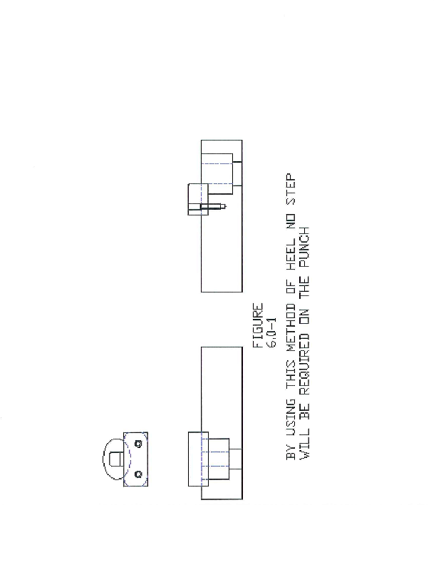
12. PILOTS

Pilots must:
12.1 Be head type.
12.2 Be of positive pick-up type.
12.3 Stick through the stripper (full point diameter) material thickness.
12.4 Be inserted in the top of the die, wherever possible, with adequate stripping pressure.
12.5 Are to have access through the bottom of the die so knocking out the pilot is possible.
12.6 Not to be mounted in the stripper.
12.7 The first pilot will be ½” longer on progressive dies then others to aid in starting the die strip. The pilot diameter may be slightly less “.002-.005 then normal to reduce metal pickup during operation.

13. PILOT BUSHINGS

Pilot bushings must:
13.1 Harding bushing to be used not to be head type.
13.2 Have a 45 degree x .020”/0.55mm chamfer on the inside diameter.
13.3 Be of standard length. Be installed in the die so that change is possible in the press. (With use of a key, screwed to the die section or sub-plate, to hold the bushing in).
13.4 Have access hole clearance through the bottom of the die shoe so that knocking out the bushing is possible.

14. DRAW AND FORM PUNCHES

Draw and Form punches must:
14.1 Be made from D-2 with Arvin Thermal Diffusion coating or equivalent (Note: Form dies (horns) must be made from A-2 or equivalent material and should be heat treated 60-62HRC for coating).
14.2 Have draw rads large enough thus preventing premature pick-up (2-4 times material thickness).
14.3 Wipe all the way past the part, wherever possible.
14.4 Be supported with a heel block in conjunction with a hardened O-1 wear plate.
14.5 Have potential to suit ready benders if possible.
14.6 Must wipe the part, not bottom out on rads in the punch.

15. CAMS

Cams must:
15.1 Be of by-pass (which are used to chamfer holes) at 10 DEG. so that raising and lowering of the ram of the press
will not change the chamfer size. (Fig. 14.0-2)
15.2 Have a shim able insert to allow for adjustment, when necessary. (Note: The driver must by-pass the cam a minimum of 1” or 25.1mm)
15.3 Be built as per cam designs. (Figure 14.0-1 and 14.0-2)
15.4 Be designed so that strip removal is easily done in the press. (This is done using a longer travel for the cam.)
15.5 Cam guides must be of box type with removable retainer plates. (Figure 14.0-1 and 14.0-2)
15.6 Stripper bolts minimum (3/8”/10mm) and easy accessible.
15.7 Have cam strippers that are returned activated by self contained nitrogen gas springs. Dadco Brand Drop-ins.
15.8 Have hardened 0-1material (52-54HRC) strippers with set screws to hold in stripper bolts and additionally secured with blue Loctite.
15.9 Screws for punch holders must be accessible through stripper in relation to (Figure 14.0-1).
15.10 Cam-pierce station: All die buttons must have slug retention. If die buttons are special made, a three spiral retention groove is acceptable.

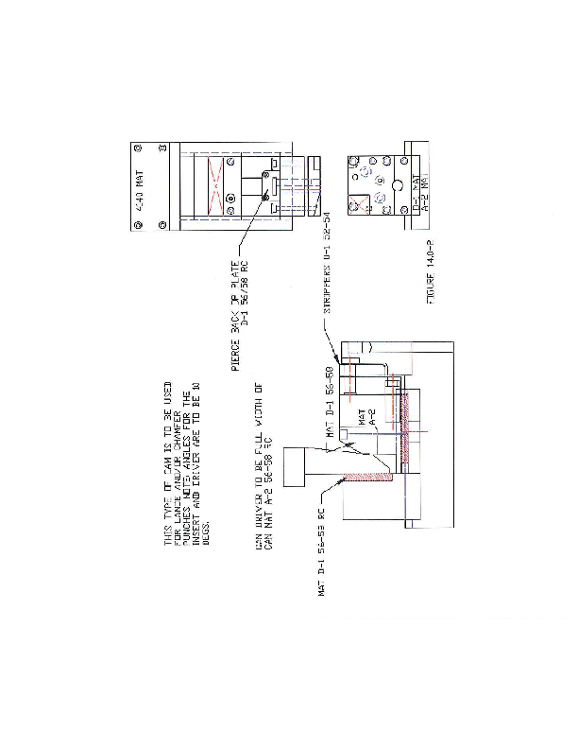

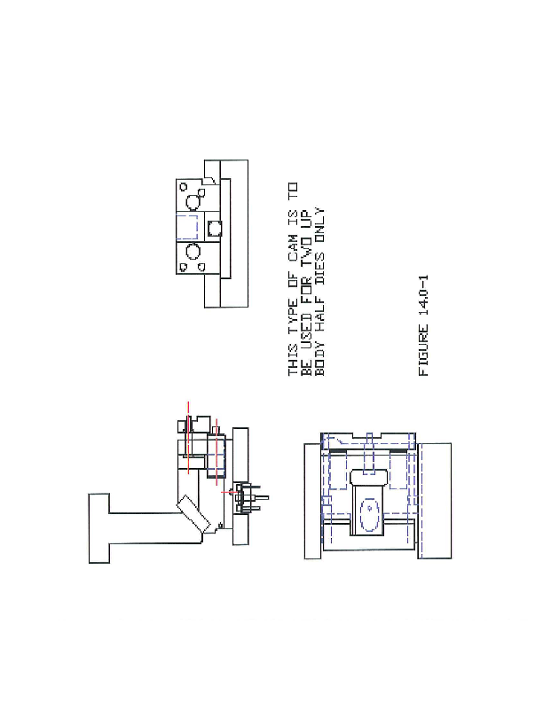

16. FRENCH STOPS

French stops must:
16.1 Not be used in conjunction with die protection (no pivoting French stops).
16.2 Be used on both sides of the strip. The strip should be cut a minimum of .150/3.8mm per side for French stops.
16.3 Have hardened inserts so that they can be easily replaced when worn.
16.4 Be located within .002”/0.05 of the punch for the French stop.
16.5 Guide rails to which French (positive) stops are mounted should be keyed or pocketed not doweled.
16.6 Be a minimum of 0.250”/6mm higher than lift height of strip.

17. KEEPER BLOCKS

Keeper blocks must:
17.1 Be made of two pieces. (Figure 16.0-1)
17.2 Be made from M.S. (case hardened) with a pre-hardened 4140 top plate screwed into position (not welded).
17.3 Mild steel (case hardened) block must have one screw holding down block to die shoe at all times.

18. NITROGEN MANIFOLD

Nitrogen must:
18.1 Be in the form of either Hyson or Forward Brand manifolds unless otherwise approved by Camaco (Note: Manifolds must cover the complete die shoe unless otherwise specified). No linked nitrogen cylinders without approval.
18.2 Have gauges mounted on the front of the die recessed back min. ½” from the edge of the die shoe and guarded with easy access, easily seen front and back and will not interfere with eye bolts.
18.3 Be of standard type.
18.4 Not be pre-loaded. (Note: Nitrogen cylinder tonnage is to be specified by Camaco so that certain sizes can be standardized (standardized sizes are 1, 2, 3, and 4 ton).
18.5 Be of standard type (Hyson, Forward).
18.6 Be of quick connect type. (not screwed)
18.7 Individual nitrogen cylinders when used can be Dadco or Kaller brand

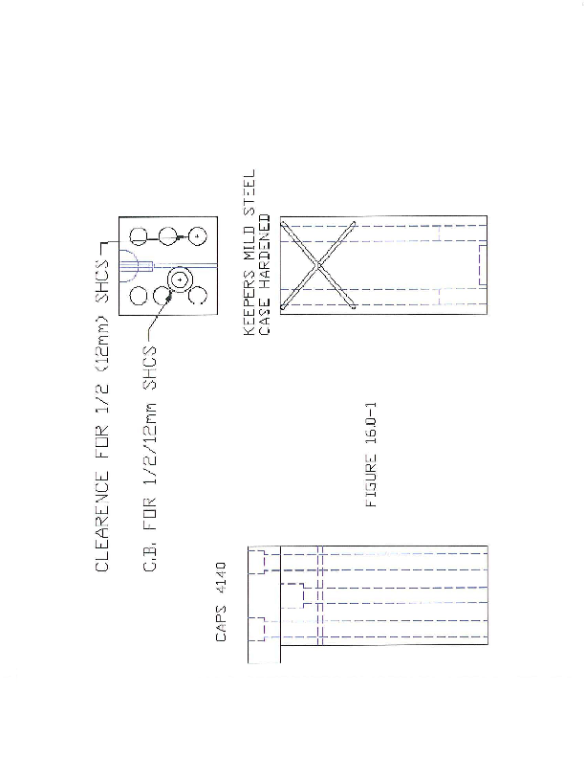

19. GUIDE RAILS

Guide rails must:
19.1 Be made from 0-1 or equivalent hardened material (and ground), and a thickness of 1.0”/25mm. The stock pan should be a minimum thickness of .375”/10mm.
19.2 Be keyed or pocketed a minimum 3/8”/10mm deep with use of heavy stock material. Note: Rails are not to be mounted on the ends of sub-plates.
19.3 Be equipped with pull dowels.
19.4 Be made in two pieces. The body is screwed and pocketed or doweled in with a top plate screwed separately with slotted holes so that it can be slid back making strip removal in the press possible. (Fig. 24.0-1). Top plate to be drilled so access to bottom screws is possible without removing top plate.

20. WEAR PLATES

Wear plates must:
20.1 Be made from hardened 0-1 material (58-60 HRC) or equivalent and should be a of 3/8”/10mm in thickness. This plate must have grease grooves milled in them on plates, which are used for heeling or on cams.
20.2 Be attached with flat head type screws.
20.3 When wearplates are required, they will be seated in the direction of thrust on a machined surface 90 degree to the face or wearplate.
20.4 Vendor will use standard catalog wearplates.

21. DIE PROTECTION

Die protection must:
21.1 Be installed to detect under feed, with use of a notch in the strip and a trigger stop. (Figure 20.0-1A)
21.2 This notch punch must have a minimum .020”/0.5mm rad on the corners and ejector in the center not offset.
21.3 Be installed to detect a buckle in the strip.
21.4 Be installed to detect a stuck cam. (Figure 20.0-4 A) (Note: Grooves or channels must be milled in the die shoe as to house all wires used for die protection {These channels must lead to a common area}.
21.5 Be installed to detect parts falling from the cut off (Photo Electric). See Sensor Specification. (Figures 21-A
and 21-B)
21.6 If progressive dies are built, the skeleton needs to have a sensor at the end of the tool.

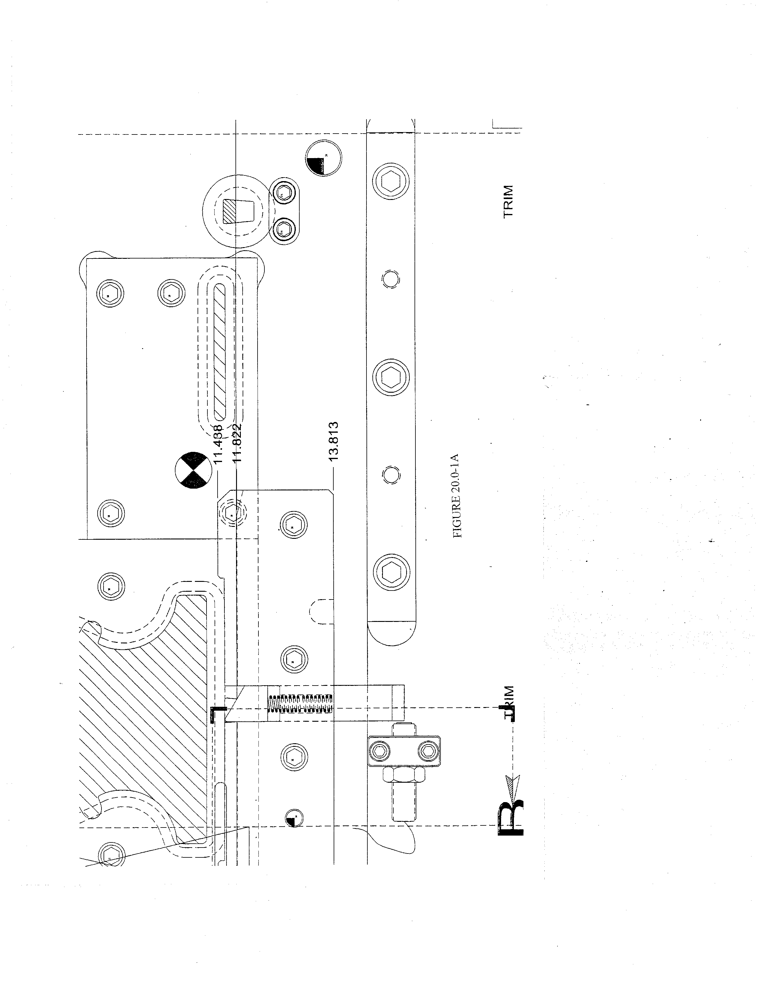

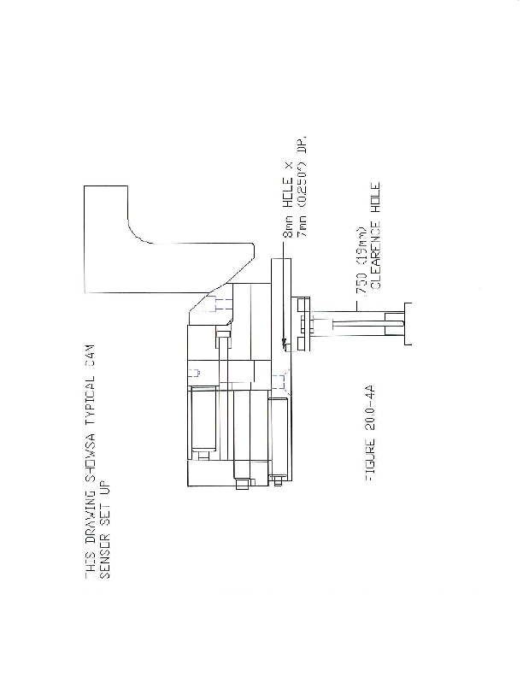

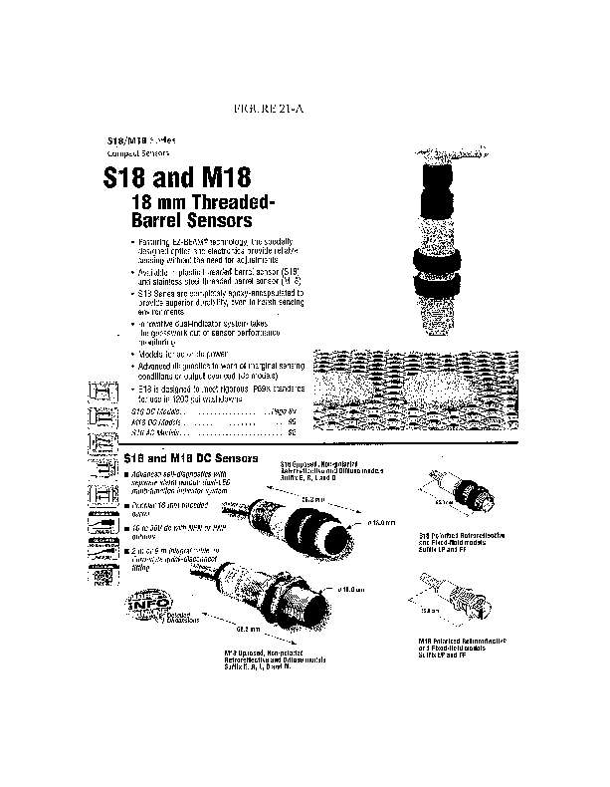

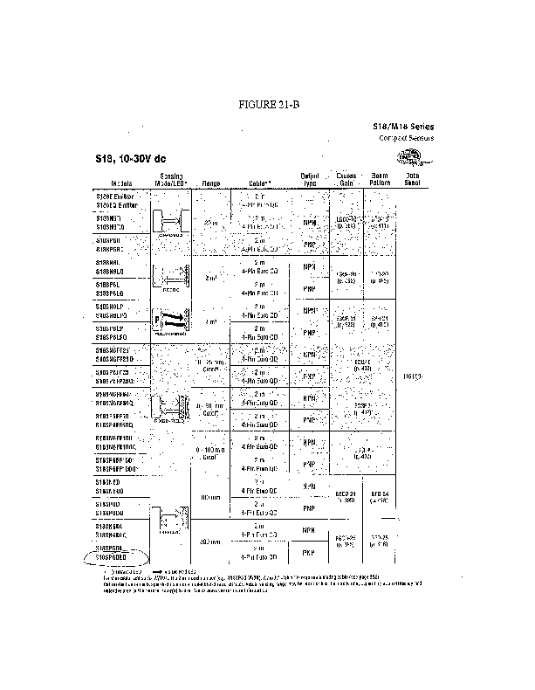

22. KEYS

Keys must:
22.1 Be of 0-1 material or equivalent hardened and ground with jack screws located for easy removal (Note: The pockets machined for the keys are to be the same size as the keys).

23. STAMPS

23.1 The die must have provisions made for the date stamp and manufacturers identification with the stamps being changeable in the press. Reference stamp holders (Figure 22.0-1). Stamp holders must be designed so that they slide in and out easily and are locked in position. When stamps are in the bottom they must be able to be removed without operator hands having to go between strip and die section. (Note: Must be discussed during design stage). (Figure 22.02 for Camaco Style).
23.2 Should be removable without removing sub-plate.
23.3 Must be used in conjunction with a bottoming block so that the stamp does not rely on the stripper pressure.
23.4 New stamp holder design is to be used.

24. PARALLELS

Parallels must:
24.1 Be screwed to the die set from the inside and be accessible without removing die sections. Mounting holes and clamping height information will be supplied by Camaco.
24.2 All locator and clamp parallels must be doweled. (Full dowels only).
24.3 Be 2”/50mm minimum width, or alternate at Camaco’s request..
24.4 Have minimum of four ½ SHCS/M12 SHCS per parallel and should be counterbored.
24.5 Be located under form station.
24.6 Risers (Parallels) to be made from C.R.S. or H.R.S. and to be finished on top and bottom. Minimum thickness will be 1.5” and must increase with tonnage. Stamp corresponding location numbers on front edge of die shoe and risers.
247 Parallel spacing should be in even inch increments measurements to reduce the quantity of scrap or slug trays.
24.8 Parallel clamp feet shall be machined at 2-3/8” high and slotted 1-1\4” wide for use of ¾” diameter clamping bolts.

25. STOCK LIFTERS

Stock lifters must:
25.1 Be accessible from inside the die.
25.2 Have a threaded hole on the top used for removing stock lifters.
25.3 Have a lead (if the strip lift is low) large enough to accept the start of a new strip. thus preventing the operator from prying up on the strip to start it. (Note: Bar lifters must be mounted in the same fashion). (Figures 24.0-1, 24.0-2) This is common throughout die progression.
25.4 Pressure pads need to be mounted in the stripper above material lifter guide pin.

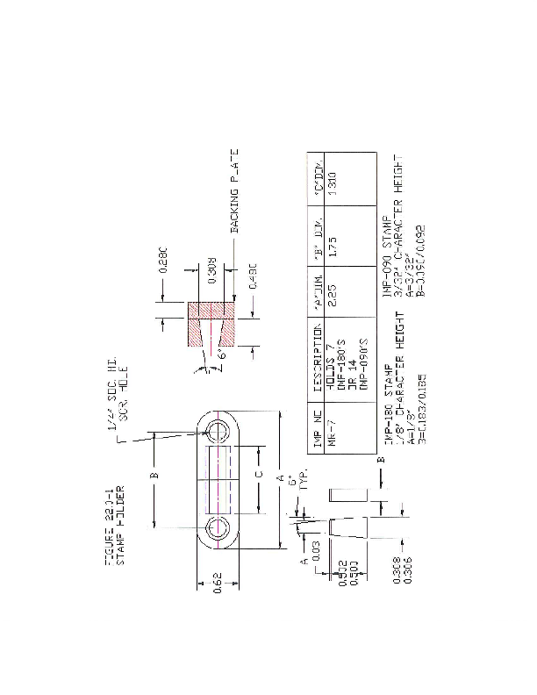

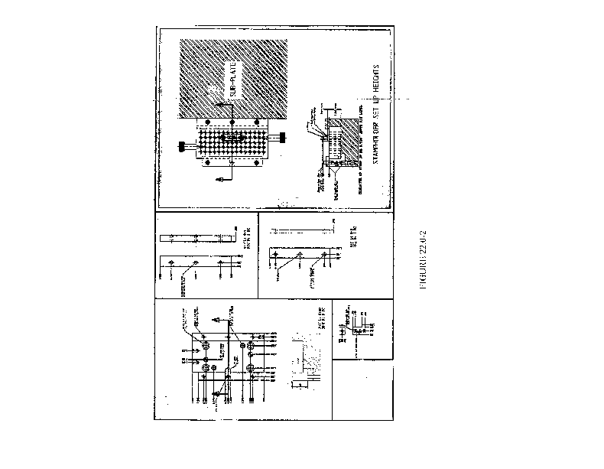

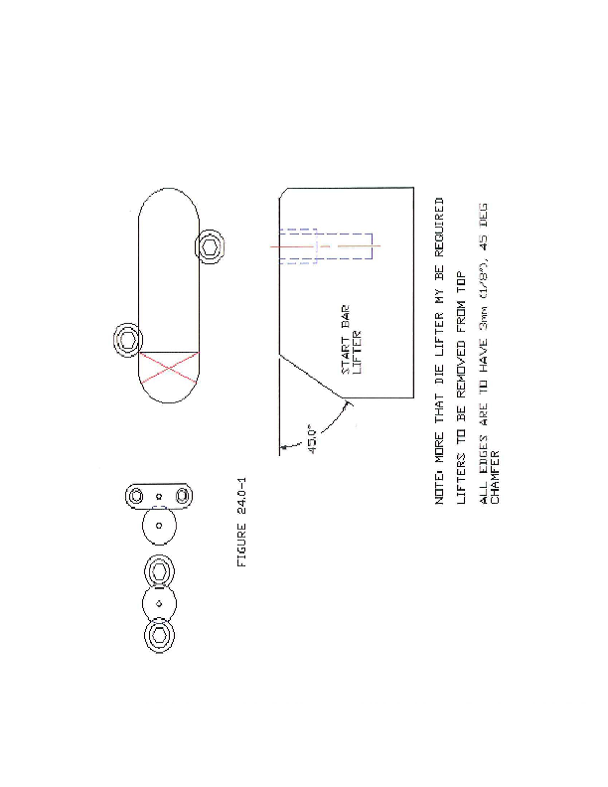
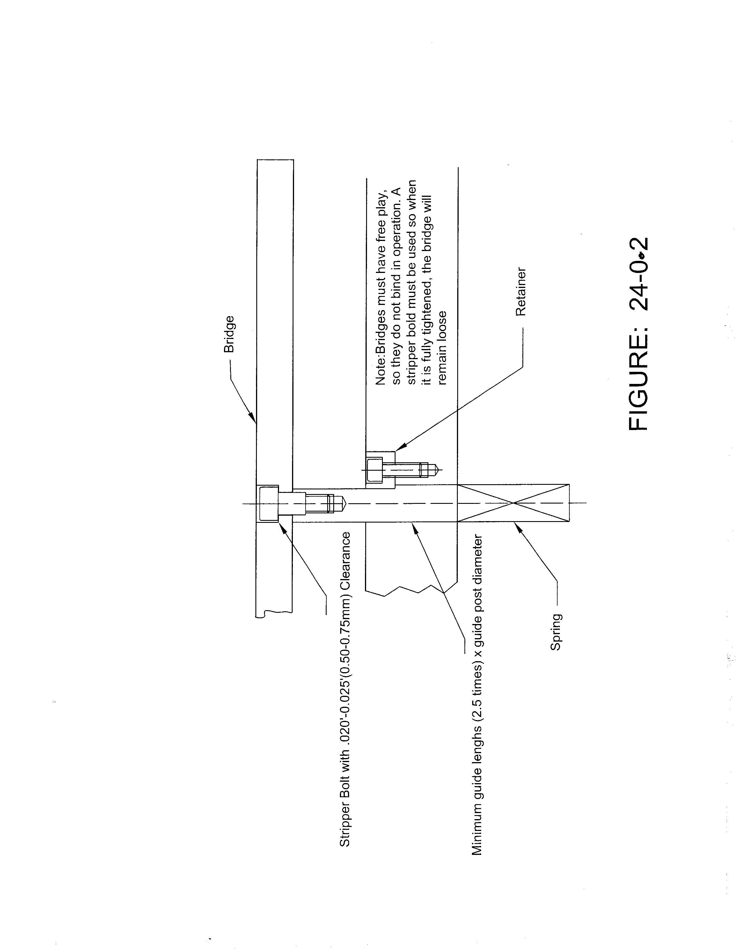

26. CUT OFF STATION

26.1 Guide the strip provided the strip is not already guided by a horn.

27. FASTENERS AND DOWEL PINS

Fasteners and dowel pins must:
27.1 Be of Holochrome brand (Metric Grade 12.9)
27.2 Be pull type dowel
  - Location of hydraulic die lifters are to match parallel location or 1-1/2” plate must installed be to the bottom parallels to allow for use of QDC system. Applies to tools running in 800 ton press as of 5/08.

28. QUICK DIE CHANGE

Quick die change must:
28.1 Be totally implemented according to information sheets supplied by Camaco.

29. SAFETY BLOCK AREAS

29.1 Vendor will provide two areas in each die for safety blocks. The areas will be located diagonally as much as possible. Locations and gap dimensions in die closed position will be determined in consultation with Camaco. Casting or weldment construction will not proceed until dimensions and locations are approved.
  - This area must be painted “Yellow” and stamped for proper placement of the safety blocks.

30. DIE HANDLING

30.1 Vendor will provide a means of handling dies that is compatible with Camaco’s lifting equipment. Large transfer tooling is lifted with cranes that have chains with loops at end. Smaller tools are handled with fork trucks in and out of the press. Parallels on dies handled by a fork truck must have two fork access areas, 6 ¼” wide each without obstacles.
30.2 Tap (4) ¾” NC or (4) 1” NC handling holes in the edge of all die shoes and punch holders, depending on die size. Holes must be placed in such a manner that tool is stable when suspended from handling holes.
30.3 Four lifting spools will be supplied on bottom of large transfer tools. Location of spools should facilitate level lifting, ease of opening of die and safe die turnover. Strength of spool will be proportional to die size and weight. Spool must not interfere with transfer equipment.
30.4 Die set-up storage pins.

31. GENERAL NOTES

31.1 The die must have provisions for slug and scrap removal from the die to automatic scrap conveyor via chutes. Chutes to be supplied by vendor. Chutes should be screwed on and be a minimum of 3/16”/4mm thick. Scrap chutes must have a minimum of 30 degree angle. Vendor is responsible to build scrap chutes to get scrap over the press table.
31.2 The die must have automatic part ejection, without the use of air from the die.
31.3 The load center point for each die must be developed and defined marked on the drawing and on the die.
31.4 Tooling must be adjustable, to allow for adjustments required due to varying material thickness and key characteristics of the part.
31.5 No slug deflectors are to be inserted into horns, etc., use the proper size drill sharpened to a 45 point where the two holes meet; you automatically make your deflector.
31.6 When cam piercing is done using a horn, the punches must not be staggered so there is even blanking pressure exerted on the horn thus preventing the horn from moving.
31.7 Drain holes must be provided for stock lifters, Cam sensors spring loaded bridges, keys in the die etc.
31.8 All cam piercing must be timed within .005”/0.10mm to create even pressure on horns.
31.9 Cam piercing of holes for key characteristics must be positioned relative to full die progression. (i.e., If making two parts at one time then the cams must be positioned in full progression, not in half progression to pilots.
31.10 All cutting clearances must be within .002”/0.05mm of the punch when clearance is .020/0.5mm side, .001”/0.025mm when clearance is less. No inserts are to be shimmed to suit above.
31.11 When forming, the die blocks must not be undercut; undercut blocks give you inconsistent forms. No form bocks are to be used in conjunction with kicker or restrictor blocks. The blank must be developed without the use of them. (Note: provisions must be made in the form blocks so that these blocks could be installed if needed at a later date).
31.12 Thread depth must be a minimum 1.5 times the thread diameter and they are to be chamfered.
31.13 A 1/16” x .750” (1.5mm x 20mm) deep slot in the guide rail. (Both front and back) must be located in the die to start the strip. This line must be located to ensure punch will not pierce half a hole.
31.14 Chutes must also be made to separate parts from scrap.
31.15 If die produces two different parts at time, then part separators must be made by the vendor.
31.16 The die must not be butchered in any way to get the parts to Cpk. The vendor must adjust or rework the die in a professional manner to get the parts to CPK at no cost to Camaco.
31.17 Tooling must be capable of producing parts consistently to a Cpk of 1.67.
31.18 Sample size to be 500 hits minimum at press speed or required strokes per/min.
31.19 30 Piece sample inspection must be done with a coordinate measuring machine, which should check every dimension on the part print. Vendor must supply data and parts for Camaco to layout and verify.
31.20 All samples are to be made in the vendor’s press, unless otherwise arranged with Camaco.
31.21 Should the vendor fail to make delivery as promised, any penalties listed on the Purchase Order or which are charged to Camaco for late delivery, will be deducted from payments towards purchase order.
31.22 The vendor is responsible for any adjustments/alterations to the die if problems are found during set up, strip start up, and a run of at least 10,000 pieces or a full coil.
31.23 To eliminate cracks in blocks (as well as to strengthen) due to heat treat, no sharp corners are allowed unless it is a cutting edge. Rads on inside corners are to be a minimum of 1/8”/3mm unless otherwise specified.
31.24 All clearance holes and slots are to be on maximum print dimension unless specified by Camaco.
31.25 All components should be stamped with material type, hardness and detail number.
31.26 Vendor must supply technical support during tryouts at Camaco’s Lorain, OH facility to assist with problems in our production environment that may not be seen at sample submission.
31.27 Camaco, with vendor’s input will come up with a corrective action plan to fix problems identified during tryout.

31. GENERAL NOTES CONT’D.

31.28 No forming or embossing using ball lock punches.
31.29 Lifting holes to be provided in components weighing more than 50 Lbs.
31.30 Vlier springs ejectors must be of the hex variety.
31.31 Die components must be foolproof to ensure proper installation.
31.32 Miss match cuts to be designed into the trim profile and part cut off. Concept of the recommended miss match to be supplied . No scallop type miss match cuts allowed!
31.33 Jack screws or pull screws (for punches) to be used throughout the die.
31.34 Spare punches, die sections, forms are to be fitted prior to die approval at Camaco after completing 500 pcs. samples with originals.
31.35 Scrap not to exceed 4.0”/100mm square.
31.36 Vendors pre-shipping tooling checklist (Exhibit C) is to be filled out and a copy sent to Camaco.
31.37 One set of hardened shims to be supplied for each cutting punch and die section. Stack height should be ½”/12mm, of 10 various thicknesses, to be agreed.
31.38 The Build Stage covers the interactive communication of information between Camaco and the supplier during the build of the item purchased. The supplier will provide a weekly progress report during the build state. (Exhibit A). This report is due each Monday. If the supplier wishes to deviate from the approved design, they must submit a request to Camaco in writing, no cost and timing impact will be accepted. This will be reviewed and answered in writing in a timely manner.
31.39 The Sample Stage covers the production, inspection, and submission of the first sample parts. For the production of first sample parts, Camaco may elect to send a representative to the supplier’s facility to observe the first production run. The supplier’s responsible for operating the equipment in a production mode if at all possible to verify hourly first piece sample as outlined below.
31.40 Dimensional Results package should include complete dimensional assessment for each of the six parts from each cavity of tool from a production run of no less than 300 pieces.
31.41 Material Certification must reference all application specifications and requirement.
31.42 If plating is included on first piece samples, there must be plating certifications included with the submissions.
31.43 Engineering standard testing requirements must be verified with accompanying certifications.
31.44 Statistical certifications are required with each shipment on critical characteristics. (Data must be included).
31.45 Material certifications are required for each shipment. Special circumstances can be considered on an individual basis.
31.46 These items, properly completed, must accompany the first submissions or the samples will be rejected.
31.47 The first piece samples should be shipped in a container clearly marked as samples and be addressed to the Quality Assurance Manager at our plant.
31.48 DE-STA-CO clamps preferred. Other brands only when approved by Camaco.
31.49 All non-functional sharp edges must have chamfered on radius edges.
31.50 Part number stamps to be provided as required. Preferred place to stamp part is in the blank die. Number stamp and/or bump block to be removable and shimable in press. Characters for retainers shall be a minimum of 3/32” in height.
31.51 All tool steel to be stamped: Material, Detail Number, and Hardness.
31.52 On large draw dies, add titanium coating after die has been ran in-house and approved.
31.53 Maximum lubricant allowed on any steel or purchased parts must not exceed 1 gran/sq. meter. This converts to .03527 ounces per 1.196 square yards.

32. STANDARD TERMS AND CONDITIONS “B”

(CAMACO Tooling-Equipment-Fixture-Gage)

32.2 General expectation: Tooling is provided on a turnkey basis with Supplier responsible for all costs associated with design, build, debug, PPAP and runoff at CAMACO. CAMACO expects supplier to show proven tool capability to produce good quality product at quoted production rates on CAMACO equipment.

- Payment Terms – 45 days after CAMACO receives payment from CAMACO customer. A 5% Sales Price PENALTY will be charged per week for every week the tool is late, day into week constitutes a full week.

- Tool Cost Audit – CAMACO and/or its customers have the right to audit tool cost. Supplier is responsible for documentation and justification of tool cost, PO may be adjusted based on the audit results.
- Tool Cost Breakdown Sheets – Supplier shall complete Detailed CAMACO Tool Cost Breakdown Sheets as part of the quote submission. Quotations without cost breakdowns will not be considered.
- Freight – Quote freight FOB CAMACO.
- Tryout Stock – Supplier will purchase sufficient material for tryout and PPAP part submission. If CAMACO provides tryout material, such costs will be charged to Supplier including cost of material, freight, shipping and handling, and administrative fee.
- Tool Design Buyoff: If CAMACO provides design support, including evaluation and buyoff, such costs will be charged to the supplier.
- Tool Buyoff and Acceptance @ Supplier plant (8 hour run)
  - Tool Shop – Tryout time and equipment to be included in quote
  - All material cost associated with tryout and runoff is the supplier’s responsibility
  - All CAMACO personnel time and travel costs will be charged to Supplier
  - Supplier is responsible for travel expenses for supplier personnel for interim progress meetings and acceptance runs.
- Tool Buyoff and Acceptance @ CAMACO facility (8 hour run) at a CPk 1.67
  - CAMACO shall charge supplier for use of facility and equipment
  - All material cost associated with tryout and runoff is supplier responsibility
  - CAMACO shall charge supplier for any support labor used for die tryout and runoff
  - Supplier is responsible for travel expenses for supplier personnel for interim progress meetings and acceptance runs.
- Delivery – Supplier will quote firm delivery. In case of any delay, all costs incurred by CAMACO as a result of this delay shall be charged to the supplier.
Supplier must execute a Bailee Bond.
- PPAP –
  - Supplier is responsible for submittal of full level 3 PPAP package including short and long term capability studies as required by CAMACO and/or its customer’s incl. 300 good parts and study for Gage R&R.
  - 300 PPAP approved parts are to be submitted to CAMACO
  - Supplier responsible for material lab testing, if required.

Change Control – Supplier responsible for tracking & documentation of tool revisions including timing, cost and cost breakdowns. All costs related to changes shall be paid only and after payment is received from CAMACO customer and only up to the quoted amount.
- CAMACO shall have the right to an off-set to the supplier invoices in order to recover for material, time and expenses incurred by CAMACO and any other costs associated with delivery and quality of the Tooling/Equipment/Fixture/Gage or Purchased items.

33 PRESS STANDARDS

The following table automatic list presses available in Camaco Lorain Mfg.

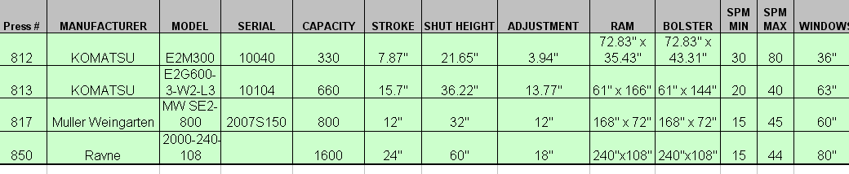

34. TOOL PROGRESS REPORT

33.1 Tooling progress report (Exhibit A), must be completed at the time the purchase order is given to tool source. Reports must be given monthly for first 50% build and weekly until tooling is completed.
33.2 The report must be given to the appropriate Program Manager providing tool progress by tool source.

35. IN-DIE LUBRICATION

Required for all dies with more than 25 strokes/minute.
34.1 In-die lubrication to be implemented prior to all forms and drawings including restricts
34.2 The lube lines must be contained in either top bottom die shoe.
34.3 Quick connect type coupler to be mounted at front and back of beginning of die.
34.4 This is to be determined by tool source and Camaco at final die design.

Attachments

Exhibit A Tooling Progress Report

Exhibit B1 Die Design Buyoff (2 pages)
Exhibit B2 Die Shop Buyoff
Exhibit B3 In House Die Buyoff

Exhibit C Vendor’s Pre-Shipping Tooling Checklist

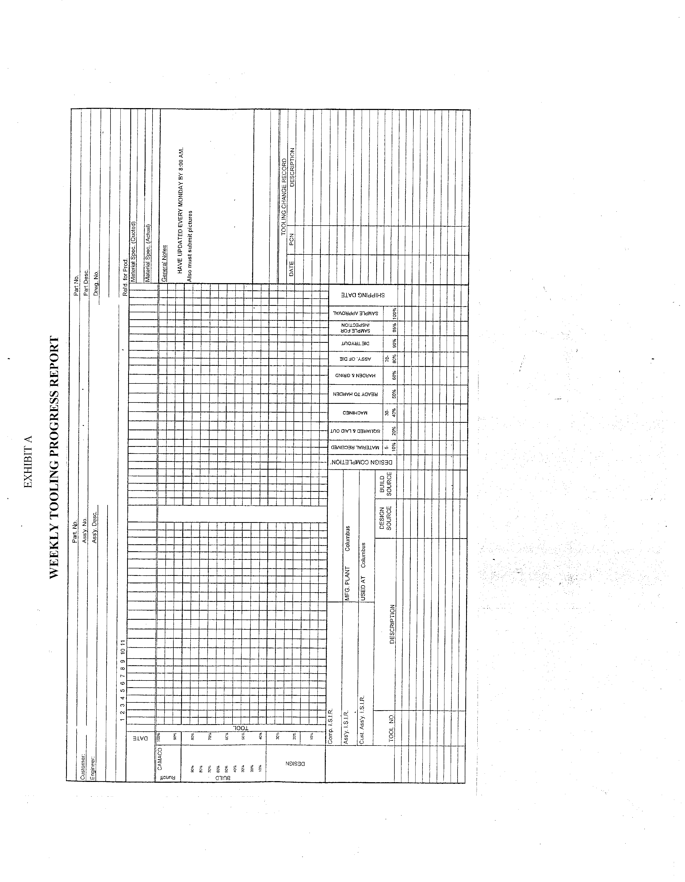
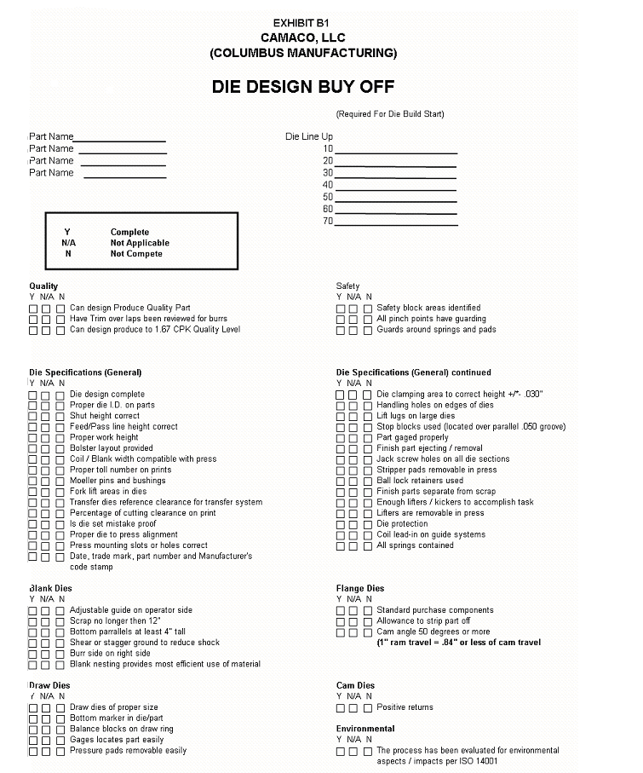



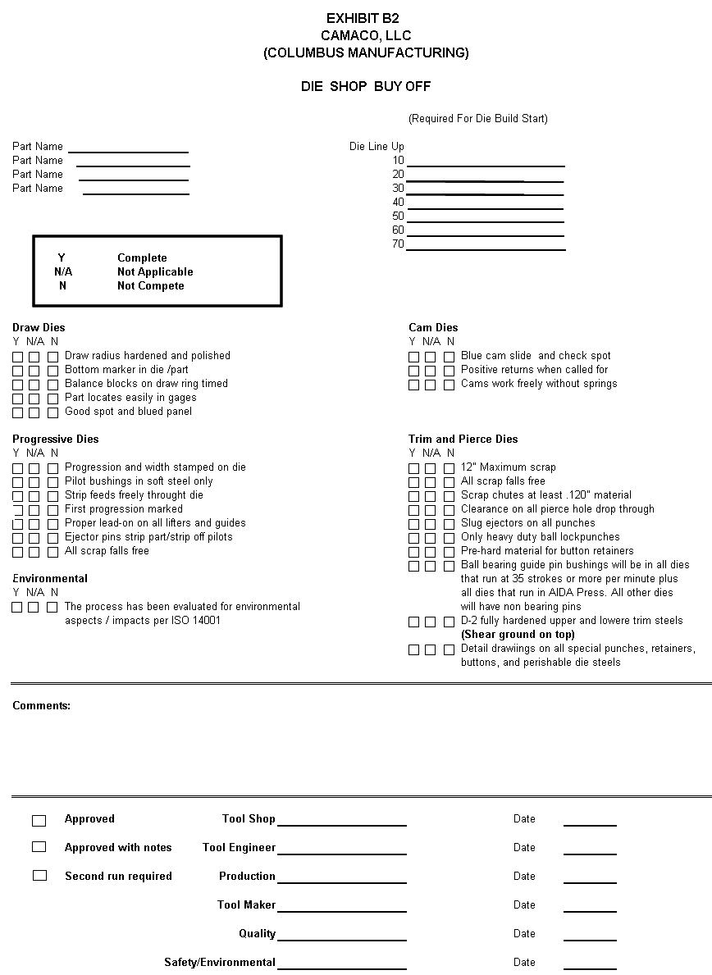

EXHIBIT C
VENDOR’S PRE-SHPPING CHECKLIST

Vendor Number:
Die Number:
Program:

- Check all strip guides and lids for proper lead ins and de-burred edges.
- Check for lift holes in die shoe, strippers and manifolds.
- Check for jackscrews in all removable parts.
- Check and install scrap chutes where needed.
- Check for buckle sensor bracket, to be installed in proper position.
- Check for slug clearance in all parallels.
- Check and make sure drain holes are not covered with parallels.
- Check all strip lifters for easy removal in press.
- Check all stripper windows, for jackscrews and to be fool proofed.
- Check for loose screws on all components.
- Check all heel blocks, they must have a slot for easy removal.
- Check all form rads, must be polished.
- Check and make sure oil lines are installed in proper position.
- Check die #, material thickness, strip width, progression, shut height and die weight must be stamped on die shoe.
- Check for stripper levelers.
- Check for strip start.
- Check for part off chutes, to ensure separating RH from LH parts.
- Stamp holders present.
- Check all pockets and cavities for drain holes.
- Check receipt of approved Camaco MSDS sheet for packaging materials.
Comments:

Signed by Manager: Toolroom Supervisor:

Returned copy to Camaco:

